Nepal College of Information Technology
Assessment
Spring 2012
Program : IT Time : 3 hrs
Semester : (II) FM : 100
Subject : Electronic Devices PM : 50

- Candidates are requested to give their answer as far as practicable in their own words.
- The figure in the margin indicates the full marks
- Attempt ALL question

1. a) Explain the properties of non linear devices. Show that diode is a non linear device. 8
b) What happens when a forward biased diode is suddenly reverse biased? Explain with necessary diagrams. 7
2. a) Explain tunneling phenomenon in tunnel diode with the help its VI characteristics. 8
b) Refer the circuit diagram below: 7
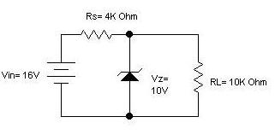
Find:
i) The output voltage
ii) Voltage across Rs
iii) Current through Zener diode
iv) Power dissipated across Zener diode

3. a) Explain input and output characteristics of common emitter configuration. 8
b) For the BJT circuit shown below, draw dc load line and locate operating point on it.(assume β=100) 7
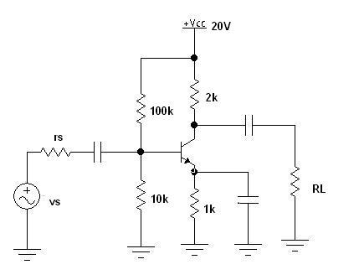

4. a) Refer the circuit diagram below. Draw its r_{e}-model and determine: r_{in}, r_{in}(stage), r_{o}(stage), voltage gain(A_{v}), overall voltage gain(V_{L}/V_{s}) and find V_{L} if V_{s}=20mV. (Take β=100.) 7
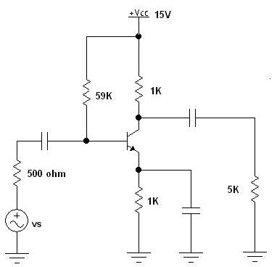
b) For the amplifier shown in the figure below the transistor has the following parameters: h_{ie}=1500 Ω, h_{fe}=80, h_{re=} 2 X 10⁻⁴ and h_{oe=} 20S. Find Z_{i} , Z_{i}(stage), Z_{o}(stage) and V_{L}/V_{S.} 8
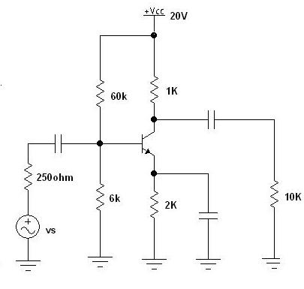
5. a) Compare BJT and FET. Explain the operation of N channel JFET. 8
OR
Explain the working principle of npn transistor with necessary diagram. Show that I_{C}=βI_{B}+(β+1)I_{CBO}.
b) Design Voltage divider bias n-JFET for 15 mA drain current and 20V drain to source voltage. Given I_{DSS}=25mA, V_{p}= -12V, assume other data if necessary. 7
OR
Design a self biasing BJT circuit with Q-point (5V, 1mA) and S=5. Take V_{BE}= 0.7V, V_{CC}= 20V and β=100.

6. a) Explain the operation of Bridge full wave rectifier. Find its efficiency and average output voltage. Why filter circuits are used in rectification? 8
b) Draw the output waveform (assume ideal diode). 7
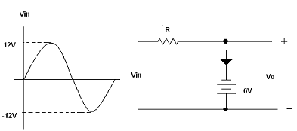

7. Write short notes (any two). 2*5
a) High frequency T-model
b) Piecewise Linear Modeling
c) Diffusion and Transition Capacitance
d) Transistor Amplifier

